STANTON HARCOURT & SUTTON PARISH EMERGENCY PLAN
Approved by Stanton Harcourt Parish Council for use from XXXXXXX.
The plan will be reviewed annually.

This document contains personal information that must be treated as private and confidential

Contents
Page | Contents
2 | Introduction and Objectives
4 | Procedure for a serious emergency event
5 | Emergency Management Team
6 | Key Contacts
7 | Communications Plan
8 | Appendix A; Additional contact information
9 | Appendix B; Special information regarding flooding
10 | Appendix C; Special Information for Snow and Severe Weather
11 | Appendix D; Survivor Reception Centre details
12 | Appendix E; Street Map of Stanton Harcourt & Sutton
13 | Appendix F; Street Map of Reception Centres
14 | Appendix G; Street Map Salt Bin Locations
15 | Appendix H; Local skills and resources
17 | Appendix I; Incident Log
18 | Appendix J; Vulnerability Register

Distribution List

Name/Place | Format
TBC | Loose leaf binder
Parish Council members | Electronic pdf
Other Emergency Team members | Electronic pdf
District Councillor | Electronic pdf
WODC Emergency Planning | Electronic pdf
OCC Emergency Planning | Electronic pdf
Stanton Harcourt Parish Council website  (without some appendices and or personal information) | Electronic pdf
Stanton Harcourt Primary School | Electronic pdf

Record of Revisions

Revision Number | Reason | Date Issued | Amended By
1 | Initial issue | XXXXXXX

INTRODUCTION
Nearly all emergencies affecting the community will be dealt with routinely by joint response of the emergency services, local authorities and the major utilities.

However, there may be occasions when the arrival of outside assistance is delayed, and the community will need to help itself.

This document has been created by Stanton Harcourt Parish Council to provide contacts and a basic framework for managing the initial stages of a major emergency that may threaten the safety and welfare of the community, its people, livestock and property. It is not the intention of this plan to replace in any way help from the recognised emergency services.

The responsibility for keeping this plan up to date lies with the Chairman of the Parish Council.

Objectives of the Plan
The purpose of this plan is to provide information for:
The Parish Emergency Management Team, The Emergency Services, Oxfordshire County Council and West Oxfordshire District Council, in the event of a major incident which may threaten the safety and welfare of the community, both residential and employed, property and livestock.

The Plan achieves this by:
- Identifying the risks to the community and taking action to mitigate them

- Providing key contact details for the Emergency Management Team, Key Community Resources, the Emergency services and Local Authorities

- Identifying resources in the immediate local community available to assist during an emergency

- Identifying vulnerable people in the community and developing plans to assist/protect them

- Provide a framework to keep the community informed of Emergency Services actions, Parish Council assistance and Residents’ personal responsibilities.

Definition of area covered by this plan
Stanton Harcourt Parish is approximately 1400 Hectares (3460 acres) in size comprising the communities of Stanton Harcourt Village, Sutton, Blackditch and West End. The parish is rural in nature forming part of the catchment area for the River Thames and River Windrush. The parish is sandwiched between the River Windrush to the west, River Thames to the East and Limb Brook to the north and is dissected by Blackditch watercourse.
There are twelve farms (Pink Hill Farm, Tawney’s Farm, Pimm Farm, Cutmill Farm, Friar’s Farm, University Farm, Cox’s Farm, Lower Farm, Manor Farm, Blackditch Farm, Sutton Farm, Nicholls Farm), two mills on the River Windrush, a Leisure Park, Gravel Pits, Lakeside Industrial Park and Sutton Farm Industrial Estate located within the parish. Numerous listed buildings are located within the Parish.

Potential Emergency Risks that might impact Stanton Harcourt & Sutton
While an episode of flooding is probably the most likely cause of any future emergency, the location of our Parish does not preclude other possible emergency situations.

- The Parish lies just to the ??? of a major military airport and is regularly over flown by military and private aircraft and particularly helicopters.

- Sustained failure of electrical or water supplies which may then threaten lives in the community.

- Damage and injury caused by severe weather or prolonged spells of severe weather or snow restricting movements.

- Gas leaks or explosions, a major fire or building collapse requiring evacuation of part of the community.

Our area covers the Parish of Stanton Harcourt and Sutton, comprising some ??? private dwellings, the Stanton Harcourt Primary School, a Pre-school/Nursery and an Industrial Estate.

Dix Pit could be classed as hazardous because as a minimum they accept gas cylinders, oil and chemical, let alone the underground waste storage.

PROCEDURE FOR A SERIOUS EMERGENCY EVENT
NOTE: remember to take all reasonable steps to avoid causing harm to yourself and others

Call 999
Give them the following information:
  - Your name
  - Your contact number
  - Details of the incident
  - Exact location
  - Emergency Services requested
  - Estimated casualties
  - Hazards & road blockages

SUBSEQUENT ACTIONS IN THE EVENT OF A POTENTIAL EMERGENCY

- Contact the Emergency Management Team (Page 5)
- Start a log (Page 14)
- Contact the District Council Emergency Centre (Page 6)
- Contact Key Holders (Page 6)
If decision is made to open a Survivor Reception Centre

- Contact the Volunteers Leader (Page 5)
- Contact schools and those at risk (Page 6 and 15)
- Assist Emergency Services as required with the resources at its disposal, or if Emergency Services cannot offer immediate help, co-ordinate efforts to mitigate the impact of the threat.

- Designate a Central Co-ordinator, and establish a communication and coordination centre in an appropriate meeting centre. (Page 7)

- In the case of severe fire, inform the local garages who store hazardous materials and also pass this information on to WODC emergency coordinators (Page 8)

Remember local resources are limited: in a declared emergency the Emergency Team will only do what is essential to protect lives and property.

EMERGENCY MANAGEMENT TEAM
The legal responsibility at County level for calling an emergency and delivering a response lies with The Emergency Services (ES), Oxfordshire County Council (OCC), West Oxfordshire District Council (WODC).

But, if a serious incident is District or County wide, Emergency Services may be delayed.
In the absence of the regular emergency services, the Stanton Harcourt and Sutton Parish Emergency Plan will be activated by the Chairman, or in his absence the Vice Chair / Clerk / Other Councillors / or members of the Emergency Team.

The Plan will be the framework for self-help response until the services arrive as far as parish resources allow

Parish Council Emergency Responsibilities:
Advise local residents what the emergency organisations plan to do.
Follow the requests made by the emergency services and the local authorities. Maintain a contingency plan to cope with a serious situation until the Emergency Services arrive.
Keep people informed so that they can help themselves.
Ensure as many vulnerable people as possible are contacted and assisted.

Emergency Management Team contacts:
Name | Contact Number | Mobile
Chairman of the Parish Council Charles Mathew
Vice Chairman of the Parish Council Matthew Judson
Clerk to Parish Council (Trudi Gasser)
Chairman of the Village Hall Committee (Jane Eagle)
Councillor Graham Dixon-Brown
Councillor Jose Eaton
Councillor Gill Sellars
Councillor Joe Deane

West Oxfordshire District Council Contact:
 | Contact Number
District Councillors:
Steve Good
Hilary Fenton

District Council Emergency Planning Officer (EPO).
Mon – Fri (time to time) | 01993 861000
Weekends/Out of hours

Key Contacts
Service | Telephone
Oxfordshire County Council, Emergency Planning | In an Emergency 999  01865 323765  01865 792422  (outside office hours will be directed to relevant service)
Oxfordshire Fire & Recue | 01865 842999 ( 24 hrs)  In an Emergency 999
Oxfordshire Highways | 03453101111
Southern Electric Emergency Numbers | 0800 0727282  0345 0721905
Gas National Emergency Number | 0800 111 999
Environment Agency: Floodline  Emergency | 0345 988 1188  0800 80 70 60
Thames Water | 0800316 9800  0800 714614
Thames Valley Police | 101 Non Emergency.  In an Emergency 999
Stanton Harcourt Primary School | (school hours)  (out of hours)
Preschool and Nursery (during school hours)
Cottsway Housing | 01993 890000  (24 hour line)  08008766366

Primary Survivor Reception Centre
Premises | Function | 24 hr Contact Number and Key Holders
Stanton Harcourt Village Hall | Reception Centre with kitchen

Emergency Communication Plan.
If telephones are affected and road traffic is not moving freely, communication within the community, and to outside assistance, can be severely hampered.
A member of the emergency team will be tasked with listening to local and national radio stations which will enable the community to assess the general situation and also to hear messages from the emergency services.
All information and actions will be reported back to the Central Co-ordinator for cascading and decisions.
Communications between the Emergency Team will be by mobile phone assuming these are functioning, otherwise by written messages using the volunteers as couriers. A supply of cards will be maintained in the plan copy in the New Beaconsfield Hall.
Contacting Vulnerable Residents is a Priority. In the first instance, contact should be made to Cottsway and direct to the Care Homes in the area. Other vulnerable residents known to the Emergency team members will also be contacted.
For an extended emergency such as severe weather, the village website will be used to provide an up to date situation report on a daily basis.

Pets and Livestock
No provision is being made in this plan for domestic pets or livestock. The owners are encouraged to make their own emergency plans.

Parish Council Liability
The Parish Council insurance covers volunteers working on behalf of the community. However it is the responsibility of all volunteers to only undertake tasks that they feel competent to do and to avoid at all times putting themselves or others into danger.
Under no circumstances should any volunteer use machinery or equipment for which they are not fully trained.
This plan has been produced in good faith by the Stanton Harcourt Parish Council, however no liability can be accepted for any inaccurate information or for circumstances arising from the use of this plan.

APPENDIX A ADDITIONAL USEFUL CONTACT DETAILS,

Organisation | Tel Number | Comments
Eynsham Medical Centre  Long Hanborough Surgery  Urgent Out of Hours: NHS 111  Pharmacy | 01865 881206  01993 881330  111 | Dispensary Opening Times: Monday – Friday 8:30am – 6:30pm (Closed between 1:00pm – 2:00pm)
Neighboring PC Emergency Contacts
Thames Water | 0800 714 614 | 24 hr leak line
Electricity Suppliers | ?? | ??
Highways Agency | 01865 815930
Network Rail 24 hr helpline | 03457 114141
First Great Western Customer Services | 03457 000125
Brize Norton airfield | 01993 842551

Local media
Radio Stations | Frequency | Tel number
BBC Radio Oxford  Jack FM | 95.2 FM  ?? | 03459 311444  01865 315980

APPENDIX B - SPECIAL INFORMATION FOR FLOODING EMERGENCIES

ENVIRONMENT AGENCY RESPONSIBILITIES TO THE PUBLIC
- Monitor rain and river levels and make forecasts and issue flood warnings
- Communicate the risks of flooding to those at risk
- Provide information on flooding including updates on Floodline

When flood warnings are in force, local flood information can be found using the Floodline service; callers can listen to this information by telephoning Floodline on 0345 988 1188

The river level can be monitored at: https://flood-warning-information.service.gov.uk/river-and-sea-levels

All properties at risk from flooding can register for the Environment Agency’s free flood warning service, Floodline Warnings Directed (FWD).

This can be done by telephoning 0345 988 1188 and asking to be registered. To find out if your property is at risk, you can either telephone floodline on: 0345 988 1188 and ask the operator or by logging onto the Environment Agency’s website at www.environment-agency.gov.uk and entering your post code.
General enquiries to the Environment Agency can be made on: 0370 850 6506
during office hours.

SAND BAGS
An emergency supply of sand for flood protection will be provided and will be available from Stanton Harcourt Village Hall/The Green including spare bags and shovels.

GENERAL ADVICE FOR THE PUBLIC IN THE EVENT OF A FLOODING EMERGENCY
- Identify a safe place where you, your family and your pets can keep away from the floodwater.
- Gather essential items together. These include warm clothes, blankets, regular medication, a torch, food supplies, a mobile phone and a battery operated or wind-up radio.
- Turn off gas, electricity and water supplies at the mains.
- Move electrical items and valuables to a first floor or higher position.
- Floods can kill. NEVER attempt to walk or drive through any depth of floodwater.
- WAIT for the emergency services. Follow their instructions. If an evacuation order is issued you MUST comply.
- Call Floodline on 0345 988 1188 for the latest information and stay tuned to local radio.

APPENDIX C- SPECIAL INFORMATION FOR SNOW AND SEVERE WEATHER

MET OFFICE WARNINGS
Residents are encouraged to pay particular attention to any severe weather warnings issues by the MET OFFICE or published on their website http://www.metoffice.gov.uk and to take the appropriate action.

Personal Actions to consider include:
Having a provision of salt and shovels for snow and ice clearance Fitting winter tyres and having chains for the car if its use is essential.

Storing a torch and batteries in a safe place in the house in case of power cuts

HIGHWAYS
Salt Grit bins are provided throughout the village to ensure that the majority of other access roads can be kept clear by local residents who need to use their cars. Local residents may use the salt grit on the highway at their discretion to reduce danger from ice and snow.

SALT BIN LOCATION
See Appendix G for Salt Bin locations.

PARISH COUNCIL RESPONSIBILITIES
Except in severe or prolonged conditions the Parish Council does not organise any other snow clearance of paths and pavements.
Where organised parties are used to keep pavements and pathways clear the following guidance should be followed:
- Salting, gritting and snow clearance must only be carried out if it is safe to do so and no unnecessary risks are taken.
- Once introduced, organised clearance procedures must continue until the period of severe weather ends.
- A system of checks will be introduced by the Parish council to minimise the risk of neglecting previously cleared areas. All such checks must be logged
- No organised action should be taken to clear, salt or grit Highways

APPENDIX D – Survivor Reception Centre details

Premises | Facilities | Key holder and tel number
Stanton Harcourt Village Hall | First choice, able to accommodate approx ??? seated.  Cooking facilities with electricity.  Limited coach access | ???
Stanton Harcourt Primary School | Second choice, able to accommodate approx ?? seated.  Cooking facilities with electricity.  Limited coach access | ??? School hours only  ??? (out of hours)
St Michael’s Church | Limited seating facilities for approx. ???.  Cooking facilities with electricity.  Limited coach access | ???
The Harcourt Arms | Limited seating facilities for approx. ???.  Cooking facilities with electricity.  Limited coach access | ???

APPENDIX E - MAP OF THE PARISH OF STANTON HARCOURT AND SUTTON

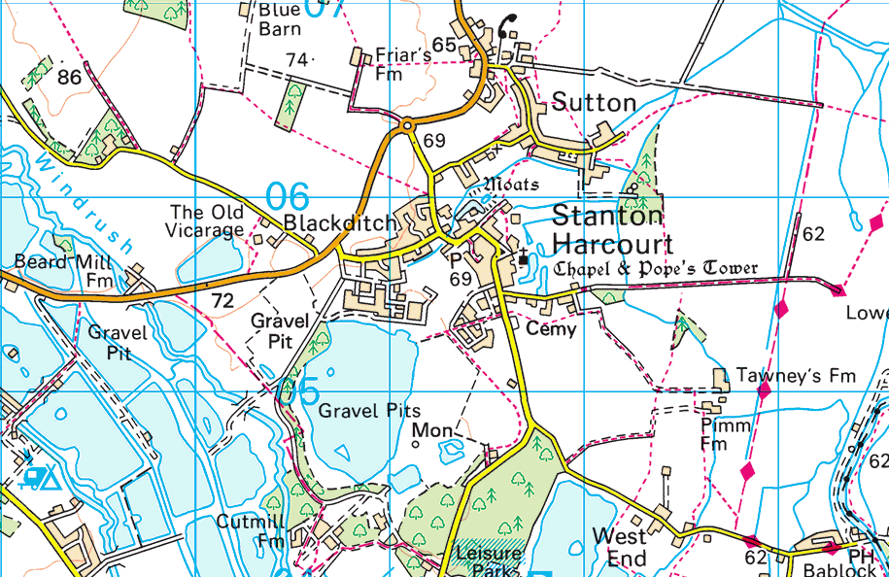

APPENDIX F - MAP OF THE SURVIVOR RECEPTION CENTRES
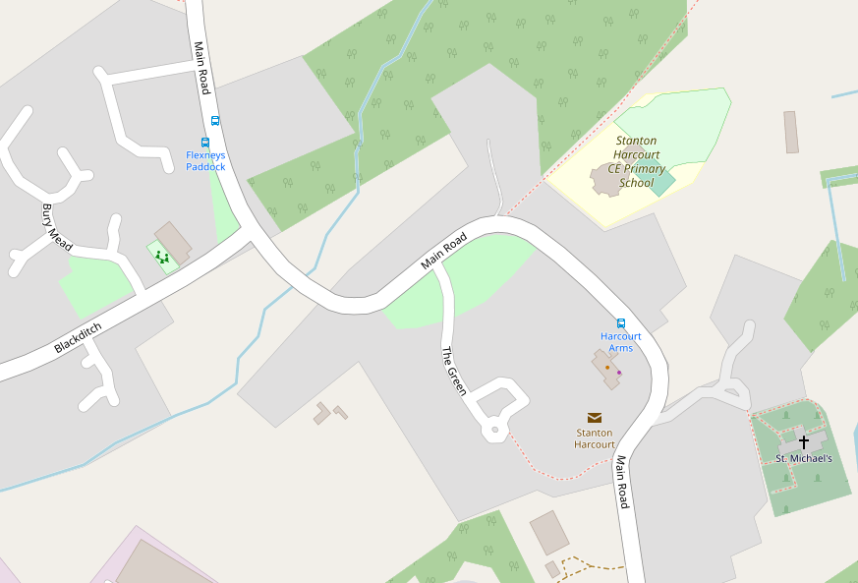

- Stanton Harcourt Village Hall

- Stanton Harcourt Primary School
2

- St Michael’s Church
1
1

- The Harcourt Arms
4
3
APPENDIX G - MAP OF THE LOCATION OF SALT BINS
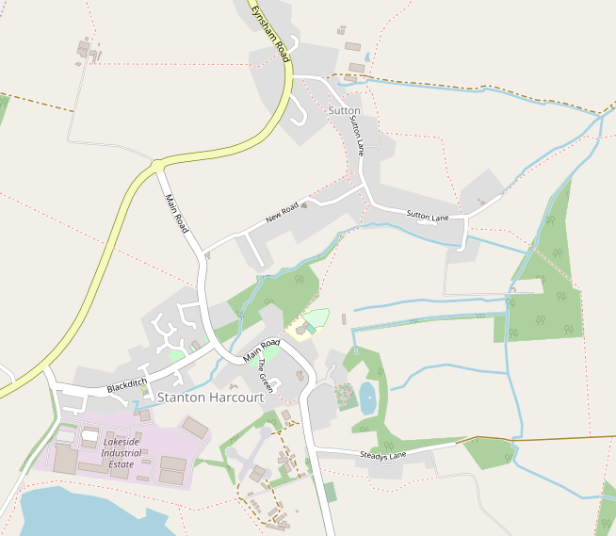

APPENDIX H - LOCAL COMMUNITY RESOURCES AND SKILLS

Equipment/ Resource | Name | Address | Tel No
Medical services
Doctor

Nurse
First Aider
Basic medical supplies
General Equipment
Tractor/digger
Lifting gear
Inflatable boat/
Canoes
Wheelbarrow Petrol driven Pump
Firefighting
equipment and
extinguishers
Sandbags and bin access
Four wheel drive vehicles
Chain Saws
Provisions
Emergency food and drink
Post Office
[Shops]

Other Equipment and Resources
Signage
Emergency lighting
Emergency Power
Emergency Supply of Petrol
Camp beds
Waste disposal bags
Electrician
Emergency Defibrillator |  | Located outside the Stanton Harcourt Village Hall. Under the supervision of the Ambulance Service | Access Code via Emergency Services

APPENDIX I – INCIDENT LOG

The information contained in this log may be of use to agencies and local authorities following an incident to establish what actually happened, please do not destroy.

Log Keeper ..………………………………………………………………

Incident …………………………………………………………………….

Page………..of…………..

Date | Time | Event | Action

APPENDIX J - VULNERABILITY REGISTER
LIST OF VULNERABLE PEOPLE & PEOPLE WHO MAY NEED ASSISTANCE

Name | Address | Tel
Cottsway Housing |  | 01993 890000  24 hour number

